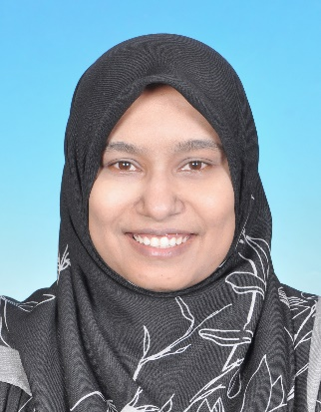
NORASIAH BINTI PAKIR MOHAMAD
SENIOR SITE ENGINEER
NO.36 JALAN DAMAI PERDANA, 14/1C BANDAR DAMAI PERDANA, 56000 CHERAS KUALA LUMPUR MALAYSIA
20 February, 1990
+60149442907 ||norasiahpakir@gmail.com
ABOUT ME ||
Our society relies heavily on the work of civil engineers. The infrastructure they build and maintain serves communities and individuals for generations. For me, this encapsulates the essence of being a civil engineer: a professional with the chance to undertake projects that not only transform our physical environment but also enhance the lives of millions of people.
key Achievements ||

Successfully managed the installation of 57 spans in the MRT project using a launching girder. Additionally, oversaw all substructure and superstructure work, including parapet, segmental box girder and drainage.  Successfully managed all structural, architectural and mechanical work for the Multi-Storey Park and Ride building (MSPR) in the MRT project. |  | Successfully monitored and installed two link bridges weighing 80 and 180 tons at TTDI MRT station. Additionally, managed warehouse projects at FIRST SOLAR KULIM, overseeing all substructure to superstructure work. Managed steel structure work at MRT TTDI Station and successfully led the VerdePalm project at Gelang Patah, including all substructure and superstructure work, along with architectural aspects.
key skills ||

LANGUAGES:  - English  - Malay |  | SOFTWARES:  - AutoCAD  - PASA  - SACS  - MS Word, Excel, Project, Power Point

qualifications ||
Bachelor in Civil Engineering | Universiti Teknologi PETRONAS (UTP), 2011-2015
- Major: Oﬀshore Oil and Gas Structure
- CGPA: 3.18

Diploma in Civil Engineering | Politeknik Ungku Omar (PUO), 2008-2011
- CGPA: 3.61

Sijil Pelajaran Malaysia (SPM) | SMK Datuk Haji Abdul Wahab, 2006-2007
- Grade: 3A 3B 2C

PeNILAIAN Menengah Rendah (PMR) | SMK Datuk Haji Abdul Wahab, 2003-2005
- Grade: 1A 7B

work experience ||
FREELANCE ENGINEER | PRESENT

My Services:
- REQUEST FOR INSPECTION(RFI) CLOSING
- Prepared all supporting documents for pending RFIs (Requests for Inspection).
- Liaised with consultants and clients to finalize documents related to structural, mechanical and architectural aspects.
- Successfully closed all documents with Code 1 status within the provided deadline.
- METHOD STATEMENT
- Prepared method statements, including job safety analysis, inspection checklists and environmental analysis.
- Compiled material lists for the project and prepared catalogue submissions.
- Prepared all documents for machinery submissions.
- Developed checklist forms.
- SHOP DRAWING
- Liaise with the site team to produce shop drawings.
- SITE MANAGEMENT
- Managed site activities, including concrete work, rebar installation and formwork installation.

SENIOR site engineer | Irama Duta Sdn. BHD.: mar 2018 - FEB 2022

As a Section Head Engineer, I successfully managed two projects (V208 and MSPR208) while working at this company. I gained a wealth of knowledge and successfully fulfilled the responsibilities entrusted to me.
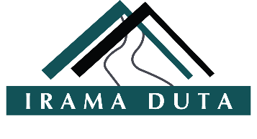
My responsibilities for the V208 project included:
  - Monitoring the fabrication of parapets and segmental box girders
  - Preparing site arrangements for launching box girders for 57 spans
  - Developing a one-month program for site planning and a one-month casting program for pile caps and pier columns
  - Managing all site progress, including substructure work (pile caps) and superstructure work (from pier columns to segmental box girder installation)
  - Preparing and presenting method statements, safety analyses and quality inspection checklists for all substructure and superstructure work
  - Creating shop drawings for pier casting, retaining walls and drainage
  - Compiling material lists for drainage installation at the segment viaduct
  - Developing programs for parapet and noise barrier installation, including cable hangers
  - Liaising with the consultant team regarding design issues and inspections for all substructure and superstructure work
  - Monitoring instrumentation installation and ongoing monitoring for the entire project
  - Overseeing drainage work for the viaduct package, including rebar installation and drainage concreting
  - Preparing method statements for defect work and monitoring defect rectification on site
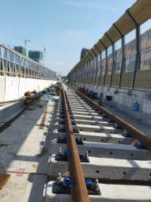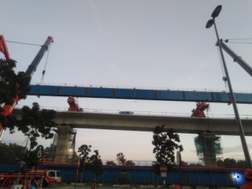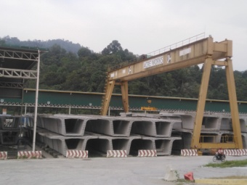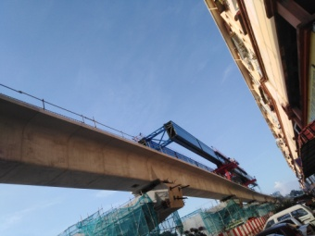

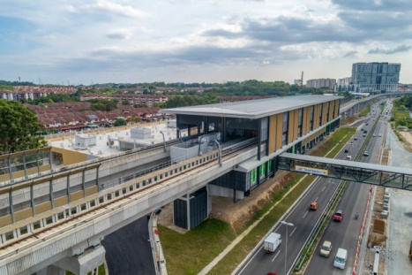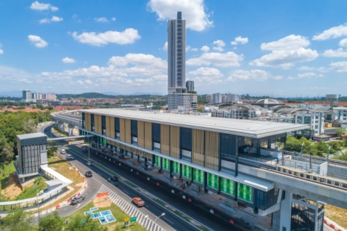
STRUCTURE WORK | ARCHITECTURE WORK | MECHANICAL WORK
Ground beam and ground slab | Waterproofing work | Lighting work
Column | Door and window installation | Fire protection system which includes fire drums, hose reel installation
Level 1 and Level 2 beam and slab | Rainwater down pipe installation | Sanitary and plumbing work which from underground to ground
Drainage work | Bollard installation | Earthing system
RC wall | Floor finishing work include tile and screeding
Staircase | Ceiling installation
Ramp | Block wall installation
My responsibilities for the MSPR208 project (MULTI-STOREY PARK & RIDE) included:

  - Managed all site progress, including substructure (ground beams and slabs) and superstructure (columns, Level 1 and Level 2), as well as architectural and mechanical work for the MSPR project.
  - Monitored all subcontractor activities related to structure, architecture and mechanical work for the MSPR project.
  - Oversaw the fabrication of steel structures, including canopies and bollards for the MSPR project.
  - Organized site arrangements for rebar installation and concreting related to structural work.
  - Prepared and presented method statements, safety analyses and quality inspection checklists for all substructure, superstructure, architectural and mechanical work.
  - Developed a one-month site planning program for structural, architectural and mechanical work.
  - Reviewed and presented shop drawings for mechanical and architectural work.
  - Compiled material lists for structural and architectural work.
  - Liaised with the consultant team regarding design issues and inspections for all structural, architectural and mechanical work.
  - Coordinated with the authority (TNB) for the handover of the TNB building adjacent to the MSPR building.
  - Collaborated with third-party designers (PE) for false work system design calculations.
  - Monitored all inspections on site with the consultant and client teams.
  - Prepared material submissions for architectural and mechanical work.
  - Reviewed all structural, architectural and mechanical drawings and prepared technical queries as needed.
  - Oversaw infrastructure work (drainage, RC walls), including rebar installation and concreting.
  - Developed method statements for defect work and monitored defect rectification on site.
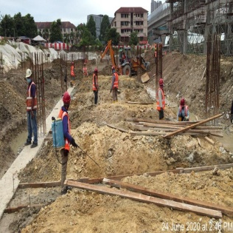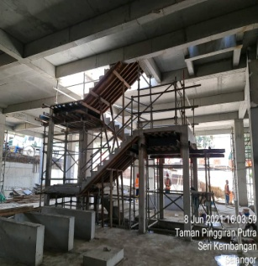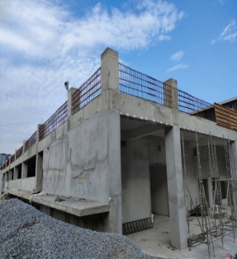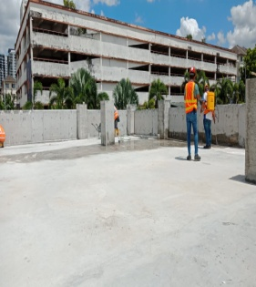
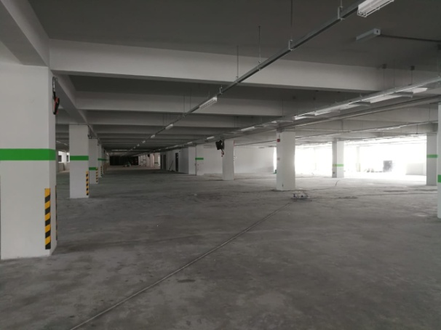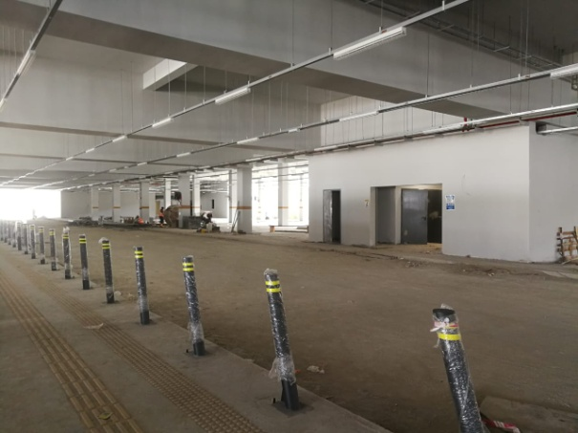
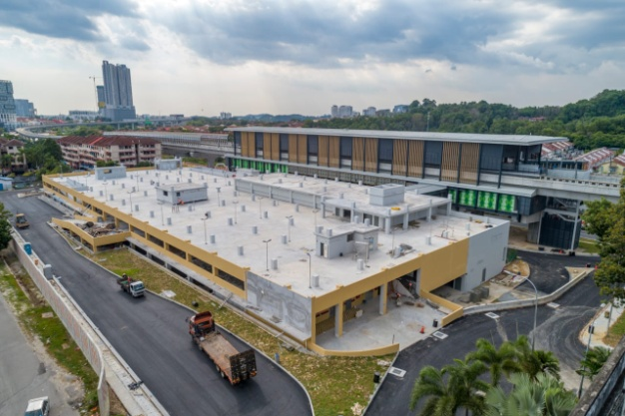
Project Engineer | Principle Perspective Engineering Sdn. BHD.: sept 2015 - feb 2018

As a Project Engineer, I successfully managed three projects during my time here, gaining valuable knowledge in the process. My responsibilities included:
- FIRST SOLAR KULIM Project
  - Successfully managed warehouse projects, overseeing all aspects from substructure to superstructure work.

- TTDI Station Project
  - Successfully monitored and installed two link bridges weighing 80 and 180 tons.
  - Served as a Project Engineer for the MRT station project.
  - Managed all steel structure work involved in the project.
  - Liaised with consultants and clients regarding on-site progress.
  - Ensured compliance with all safety requirements on-site.
  - Successfully installed both steel structure entrances.
- VerdePalm Project
  - Successfully managed the VerdePalm project at Gelang Patah, overseeing all aspects from substructure to superstructure, including architectural work.
  - Compiled and submitted all required documentation assigned to me.
  - Developed all method statements for the entire project.
  - Although my primary role was Project Engineer, I also participated in Quality Control activities as needed.

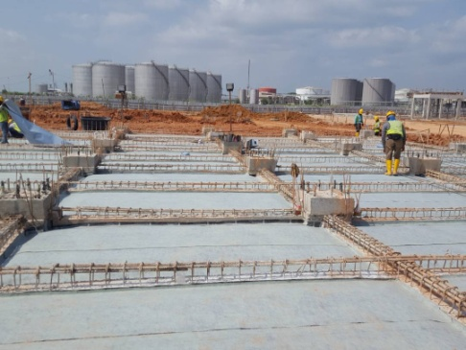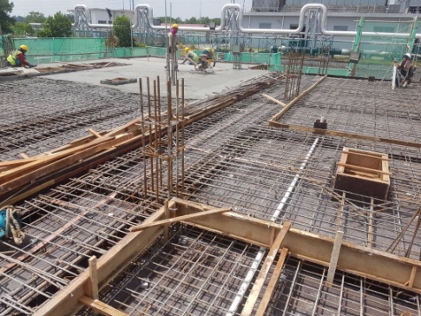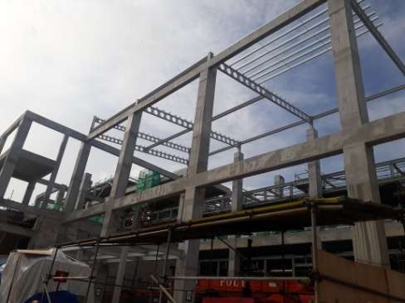

Internship | uem sunrise (uem group): jan 2014 - aug 2014

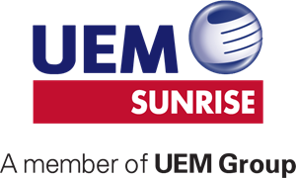
I completed an 8-month degree internship at UEM Sunrise, where I was involved in the RADIA Mixed Commercial Development project. This experience helped me learn how to manage and execute projects effectively (Project Management).

hobbies and interests ||
- Reading Novel  - Going to the Gym  - Road Cycling |  | - Badminton  - Bowling  - Exploring or Adventure Travel
references ||
Syed Nur Aizuddin  Project Manager  Irama Duta Sdn. Bhd.  Snaizuddin@i-duta.com.my  +60165534300 |  | Mohd Nazlan Bin Abu Bakar  Project Manager  Irama Duta Sdn. Bhd.  M.Nazlan@v208.com.my  +60123118585

